7:30am – 8:30am | 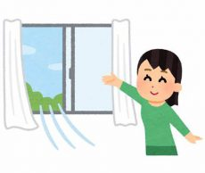  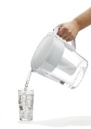  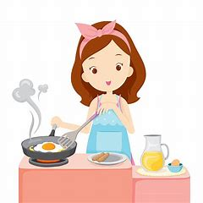  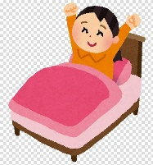  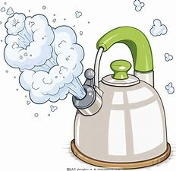
8:30am – 12:00nn | 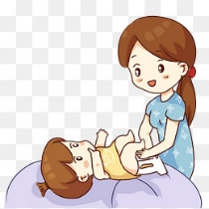  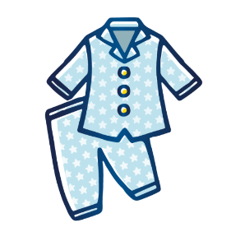  Time:___________  Drink _________ml  150ml
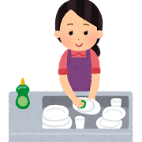
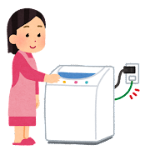
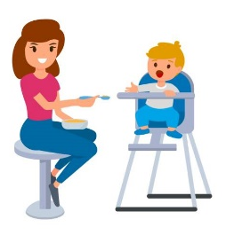

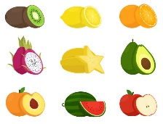
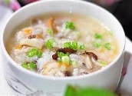

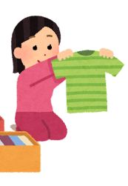
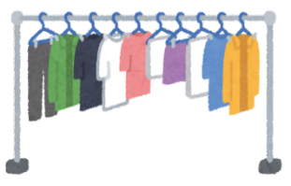
Lunch
Time:___________
How much: __5 / 1 bowl
Time: ___________
Fruit: ___________
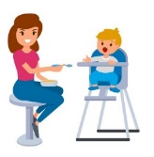
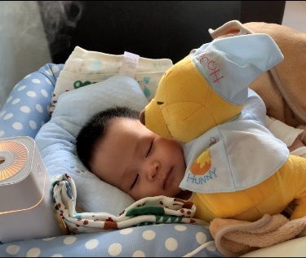
Sleep
Time:___________
How much: 0.5 / 1 bowl
Tea Time
Time: _______
Drink ______ml
- Time:
- Time:
- Time:
- Time:
- Time:

Time : to :
Time : to :
7:30am – 8:30am
8:30am – 12:00nn | Time:___________  Drink _________ml  150ml

Lunch
Time:___________
How much: __5 / 1 bowl
Time: ___________
Fruit: ___________
Sleep
Time:___________
How much: 0.5 / 1 bowl
Tea Time
Time: _______
Drink ______ml
- Time:
- Time:
- Time:
- Time:
- Time:

Time : to :
Time : to :
7:30am – 8:30am
8:30am – 12:00nn | Time:___________  Drink _________ml  150ml

Lunch
Time:___________
How much: __5 / 1 bowl
Time: ___________
Fruit: ___________
Sleep
Time:___________
How much: 0.5 / 1 bowl
Tea Time
Time: _______
Drink ______ml
- Time:
- Time:
- Time:
- Time:
- Time:

Time : to :
Time : to :
7:30am – 8:30am
8:30am – 12:00nn | Time:___________  Drink _________ml  150ml

Lunch
Time:___________
How much: __5 / 1 bowl
Time: ___________
Fruit: ___________
Sleep
Time:___________
How much: 0.5 / 1 bowl
Tea Time
Time: _______
Drink ______ml
- Time:
- Time:
- Time:
- Time:
- Time:

Time : to :
Time : to :
7:30am – 8:30am
8:30am – 12:00nn | Time:___________  Drink _________ml  150ml

Lunch
Time:___________
How much: __5 / 1 bowl
Time: ___________
Fruit: ___________
Sleep
Time:___________
How much: 0.5 / 1 bowl
Tea Time
Time: _______
Drink ______ml
- Time:
- Time:
- Time:
- Time:
- Time:

Time : to :
Time : to :
7:30am – 8:30am
8:30am – 12:00nn | Time:___________  Drink _________ml  150ml

Lunch
Time:___________
How much: __5 / 1 bowl
Time: ___________
Fruit: ___________
Sleep
Time:___________
How much: 0.5 / 1 bowl
Tea Time
Time: _______
Drink ______ml
- Time:
- Time:
- Time:
- Time:
- Time:

Time : to :
Time : to :
7:30am – 8:30am
8:30am – 12:00nn | Time:___________  Drink _________ml  150ml

Lunch
Time:___________
How much: __5 / 1 bowl
Time: ___________
Fruit: ___________
Sleep
Time:___________
How much: 0.5 / 1 bowl
Tea Time
Time: _______
Drink ______ml
- Time:
- Time:
- Time:
- Time:
- Time:

Time : to :
Time : to :
7:30am – 8:30am
8:30am – 12:00nn | Time:___________  Drink _________ml  150ml

Lunch
Time:___________
How much: __5 / 1 bowl
Time: ___________
Fruit: ___________
Sleep
Time:___________
How much: 0.5 / 1 bowl
Tea Time
Time: _______
Drink ______ml
- Time:
- Time:
- Time:
- Time:
- Time:

Time : to :
Time : to :
7:30am – 8:30am
8:30am – 12:00nn | Time:___________  Drink _________ml  150ml

Lunch
Time:___________
How much: __5 / 1 bowl
Time: ___________
Fruit: ___________
Sleep
Time:___________
How much: 0.5 / 1 bowl
Tea Time
Time: _______
Drink ______ml
- Time:
- Time:
- Time:
- Time:
- Time:

Time : to :
Time : to :
7:30am – 8:30am
8:30am – 12:00nn | Time:___________  Drink _________ml  150ml

Lunch
Time:___________
How much: __5 / 1 bowl
Time: ___________
Fruit: ___________
Sleep
Time:___________
How much: 0.5 / 1 bowl
Tea Time
Time: _______
Drink ______ml
- Time:
- Time:
- Time:
- Time:
- Time:

Time : to :
Time : to :
7:30am – 8:30am
8:30am – 12:00nn | Time:___________  Drink _________ml  150ml

Lunch
Time:___________
How much: __5 / 1 bowl
Time: ___________
Fruit: ___________
Sleep
Time:___________
How much: 0.5 / 1 bowl
Tea Time
Time: _______
Drink ______ml
- Time:
- Time:
- Time:
- Time:
- Time:

Time : to :
Time : to :
7:30am – 8:30am
8:30am – 12:00nn | Time:___________  Drink _________ml  150ml

Lunch
Time:___________
How much: __5 / 1 bowl
Time: ___________
Fruit: ___________
Sleep
Time:___________
How much: 0.5 / 1 bowl
Tea Time
Time: _______
Drink ______ml
- Time:
- Time:
- Time:
- Time:
- Time:

Time : to :
Time : to :
7:30am – 8:30am
8:30am – 12:00nn | Time:___________  Drink _________ml  150ml

Lunch
Time:___________
How much: __5 / 1 bowl
Time: ___________
Fruit: ___________
Sleep
Time:___________
How much: 0.5 / 1 bowl
Tea Time
Time: _______
Drink ______ml
- Time:
- Time:
- Time:
- Time:
- Time:

Time : to :
Time : to :
7:30am – 8:30am
8:30am – 12:00nn | Time:___________  Drink _________ml  150ml

Lunch
Time:___________
How much: __5 / 1 bowl
Time: ___________
Fruit: ___________
Sleep
Time:___________
How much: 0.5 / 1 bowl
Tea Time
Time: _______
Drink ______ml
- Time:
- Time:
- Time:
- Time:
- Time:

Time : to :
Time : to :
7:30am – 8:30am
8:30am – 12:00nn | Time:___________  Drink _________ml  150ml

Lunch
Time:___________
How much: __5 / 1 bowl
Time: ___________
Fruit: ___________
Sleep
Time:___________
How much: 0.5 / 1 bowl
Tea Time
Time: _______
Drink ______ml
- Time:
- Time:
- Time:
- Time:
- Time:

Time : to :
Time : to :
7:30am – 8:30am
8:30am – 12:00nn | Time:___________  Drink _________ml  150ml

Lunch
Time:___________
How much: __5 / 1 bowl
Time: ___________
Fruit: ___________
Sleep
Time:___________
How much: 0.5 / 1 bowl
Tea Time
Time: _______
Drink ______ml
- Time:
- Time:
- Time:
- Time:
- Time:

Time : to :
Time : to :
7:30am – 8:30am
8:30am – 12:00nn | Time:___________  Drink _________ml  150ml

Lunch
Time:___________
How much: __5 / 1 bowl
Time: ___________
Fruit: ___________
Sleep
Time:___________
How much: 0.5 / 1 bowl
Tea Time
Time: _______
Drink ______ml
- Time:
- Time:
- Time:
- Time:
- Time:

Time : to :
Time : to :
7:30am – 8:30am
8:30am – 12:00nn | Time:___________  Drink _________ml  150ml

Lunch
Time:___________
How much: __5 / 1 bowl
Time: ___________
Fruit: ___________
Sleep
Time:___________
How much: 0.5 / 1 bowl
Tea Time
Time: _______
Drink ______ml
- Time:
- Time:
- Time:
- Time:
- Time:

Time : to :
Time : to :
7:30am – 8:30am
8:30am – 12:00nn | Time:___________  Drink _________ml  150ml

Lunch
Time:___________
How much: __5 / 1 bowl
Time: ___________
Fruit: ___________
Sleep
Time:___________
How much: 0.5 / 1 bowl
Tea Time
Time: _______
Drink ______ml
- Time:
- Time:
- Time:
- Time:
- Time:

Time : to :
Time : to :
7:30am – 8:30am
8:30am – 12:00nn | Time:___________  Drink _________ml  150ml

Lunch
Time:___________
How much: __5 / 1 bowl
Time: ___________
Fruit: ___________
Sleep
Time:___________
How much: 0.5 / 1 bowl
Tea Time
Time: _______
Drink ______ml
- Time:
- Time:
- Time:
- Time:
- Time:

Time : to :
Time : to :
7:30am – 8:30am
8:30am – 12:00nn | Time:___________  Drink _________ml  150ml

Lunch
Time:___________
How much: __5 / 1 bowl
Time: ___________
Fruit: ___________
Sleep
Time:___________
How much: 0.5 / 1 bowl
Tea Time
Time: _______
Drink ______ml
- Time:
- Time:
- Time:
- Time:
- Time:

Time : to :
Time : to :
7:30am – 8:30am
8:30am – 12:00nn | Time:___________  Drink _________ml  150ml

Lunch
Time:___________
How much: __5 / 1 bowl
Time: ___________
Fruit: ___________
Sleep
Time:___________
How much: 0.5 / 1 bowl
Tea Time
Time: _______
Drink ______ml
- Time:
- Time:
- Time:
- Time:
- Time:

Time : to :
Time : to :
7:30am – 8:30am
8:30am – 12:00nn | Time:___________  Drink _________ml  150ml

Lunch
Time:___________
How much: __5 / 1 bowl
Time: ___________
Fruit: ___________
Sleep
Time:___________
How much: 0.5 / 1 bowl
Tea Time
Time: _______
Drink ______ml
- Time:
- Time:
- Time:
- Time:
- Time:

Time : to :
Time : to :
7:30am – 8:30am
8:30am – 12:00nn | Time:___________  Drink _________ml  150ml

Lunch
Time:___________
How much: __5 / 1 bowl
Time: ___________
Fruit: ___________
Sleep
Time:___________
How much: 0.5 / 1 bowl
Tea Time
Time: _______
Drink ______ml
- Time:
- Time:
- Time:
- Time:
- Time:

Time : to :
Time : to :
7:30am – 8:30am
8:30am – 12:00nn | Time:___________  Drink _________ml  150ml

Lunch
Time:___________
How much: __5 / 1 bowl
Time: ___________
Fruit: ___________
Sleep
Time:___________
How much: 0.5 / 1 bowl
Tea Time
Time: _______
Drink ______ml
- Time:
- Time:
- Time:
- Time:
- Time:

Time : to :
Time : to :
7:30am – 8:30am
8:30am – 12:00nn | Time:___________  Drink _________ml  150ml

Lunch
Time:___________
How much: __5 / 1 bowl
Time: ___________
Fruit: ___________
Sleep
Time:___________
How much: 0.5 / 1 bowl
Tea Time
Time: _______
Drink ______ml
- Time:
- Time:
- Time:
- Time:
- Time:

Time : to :
Time : to :
7:30am – 8:30am
8:30am – 12:00nn | Time:___________  Drink _________ml  150ml

Lunch
Time:___________
How much: __5 / 1 bowl
Time: ___________
Fruit: ___________
Sleep
Time:___________
How much: 0.5 / 1 bowl
Tea Time
Time: _______
Drink ______ml
- Time:
- Time:
- Time:
- Time:
- Time:

Time : to :
Time : to :

